**Project Highlights**

🔖 **Note**

Please forgive me about such a long diary, there are too many aspects to cover, I did try to minimize the content.

🌟 **Shining Points**

1. Random elements Technical

🎈 Inspirations: People get tired with fixed experience; random objects create fun.

📘 Engineering Principles: Stability. The code must ensure that the randomly generated items are reasonable, such as not placing gold coins on the wall, not placing the character's birth point and the enemy's birth point too close together.

* Maps: You never know what the next map is. There are totally 4 kinds (normal, chest, store, boss) and 10 maps, they are randomly distributed. (Fig.1-2)

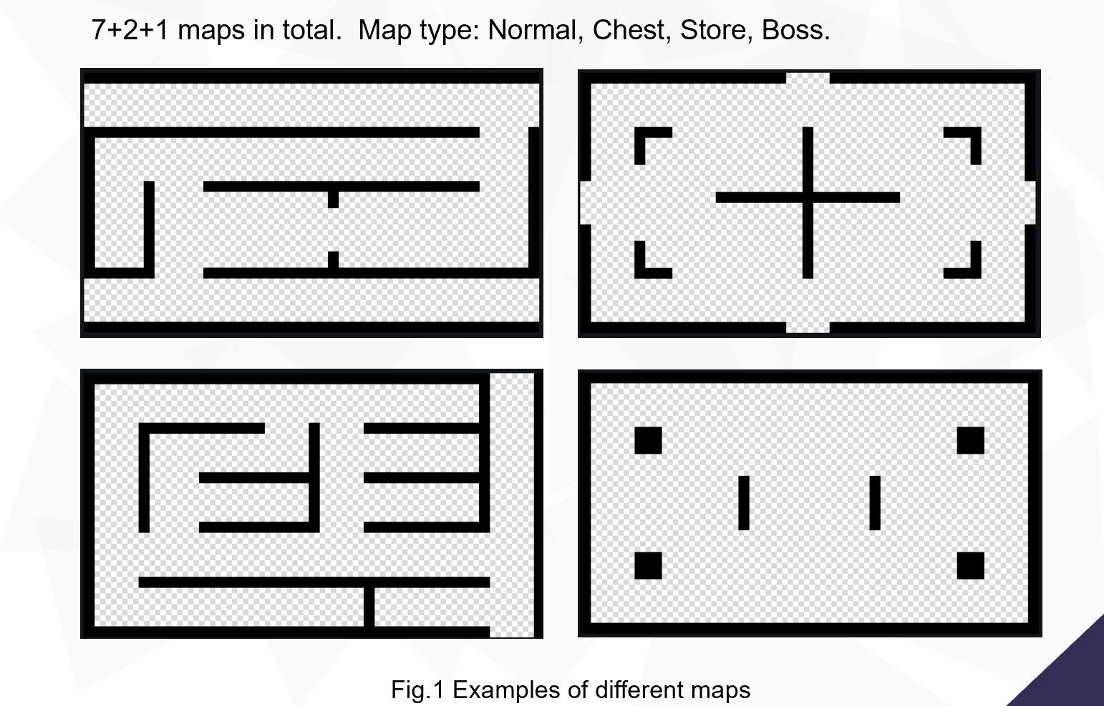

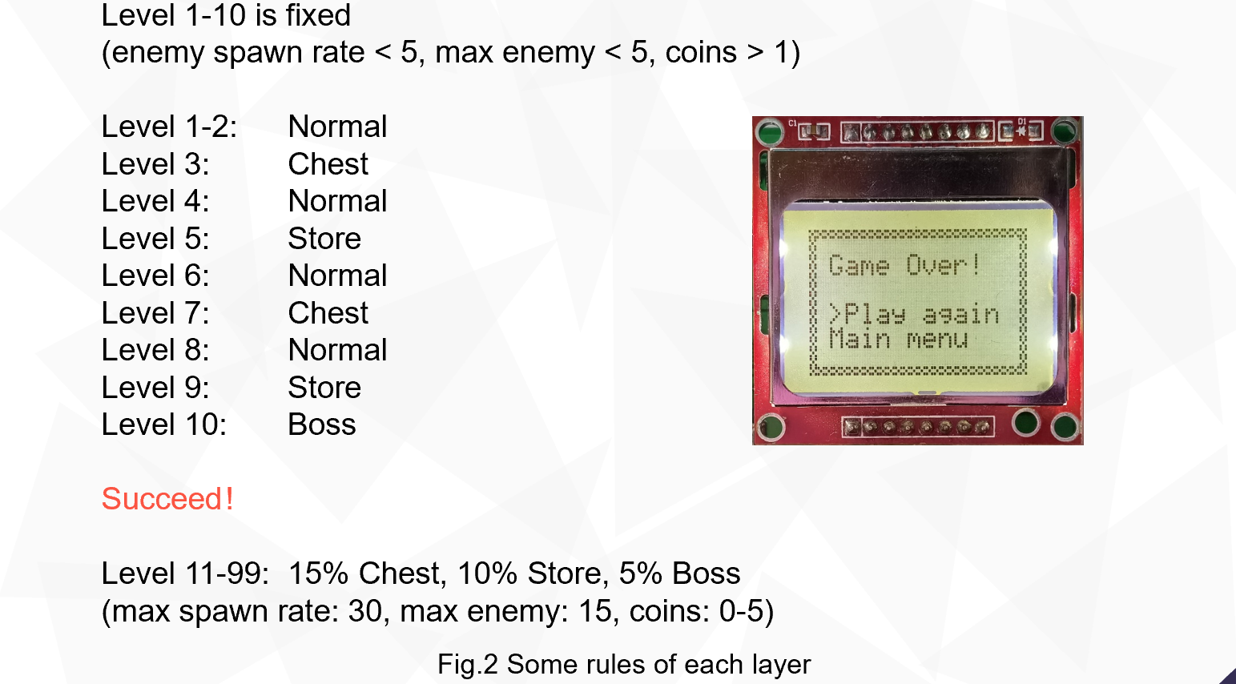

* Enemies: Five kinds of enemies, each has its special abilities (Fig.3). The type, the number, the positions they generated are all random. Enemy has both HP and SHIELD; special enemies stop shooting fire balls unless their shields are broken.

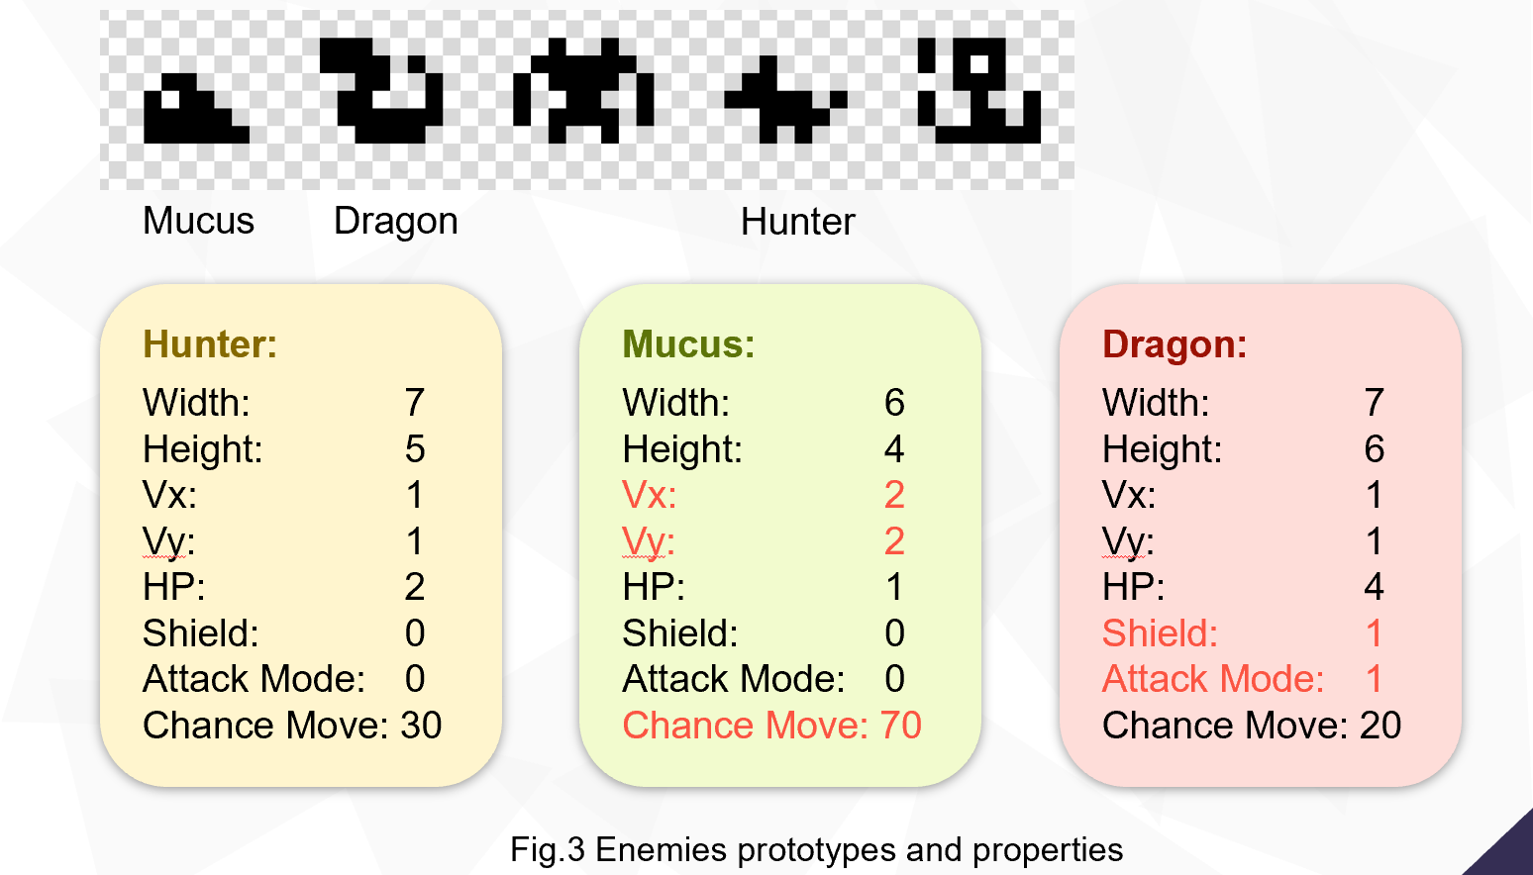

* Gold coins & birth point & success point: Randomly distributed on maps.

1. Chest System Innovative

🎈 Inspirations: Hard work needs to be rewarded.

Generally, player has 15% chance to enter a chest room. Player gets awards by unlocking the chest. Player can view his ability panel. (Fig.4)

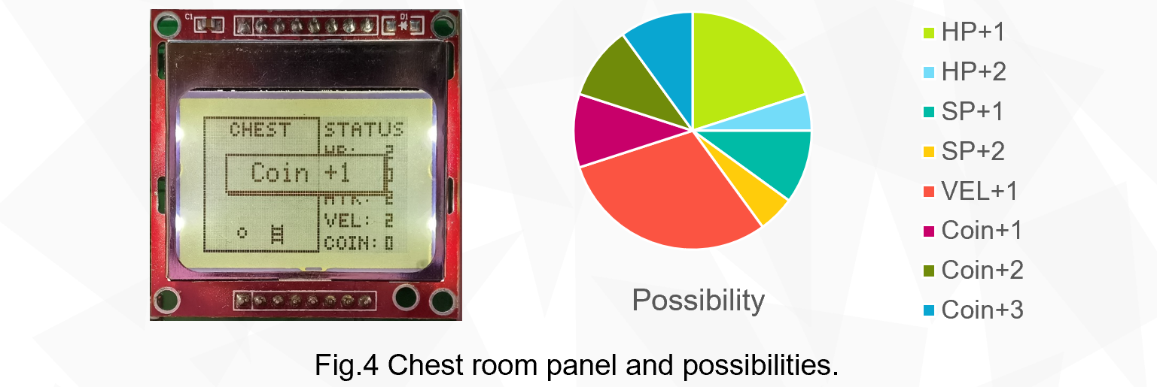

1. Store System Innovative

🎈 Inspirations: Players should be able to upgrade their equipment to face more formidable enemies.

Player has 10% chance to enter a store. Player can buy ultimate skills (SP) to kill enemies in range immediately.

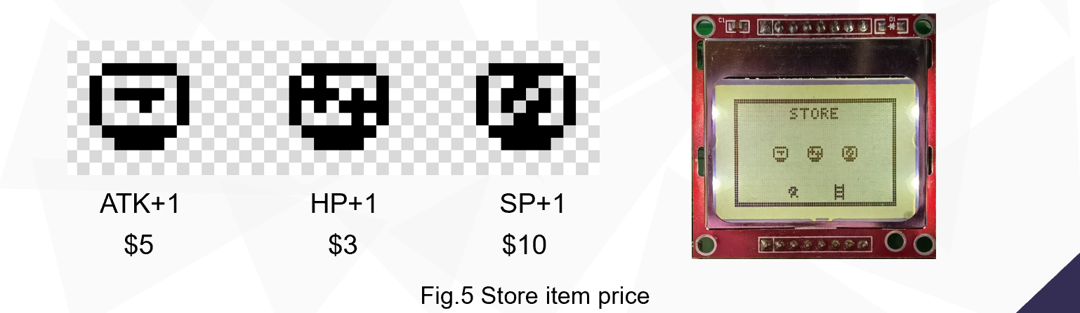

1. Tutorial System Technical

🎈 Inspirations: It is difficult for players to get started with an unfamiliar game.

📘 Engineering Principles: Integrity & Maintainability. The tutorial module inherits directly from the game module, only modifying the parameters of each layer to make it meet the tutorial requirements. I used global variables to mark the tutorial progress so that after the player completes a certain tutorial, it automatically returns to the text prompt for the next tutorial without requiring the player to press any buttons.

Five step-by-step tutorials are designed where you will learn how to move to the target point, how to pick up gold coins, open treasure chests, how to shoot, and how to use the ultimate skill. (Fig.6-7)

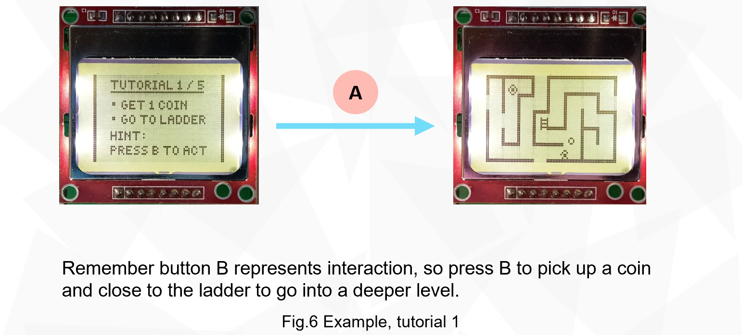

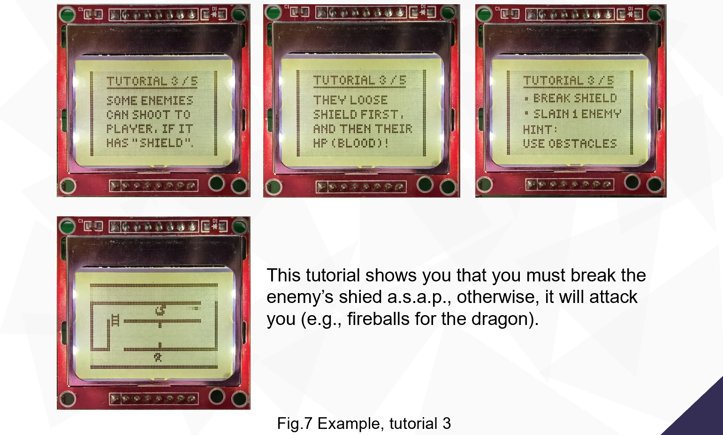

1. Achievements System Innovative

🎈 Inspirations: I love statistic data, I love to see what I have achieved in previous game.

File system is used, those records are stored in a txt file locally.

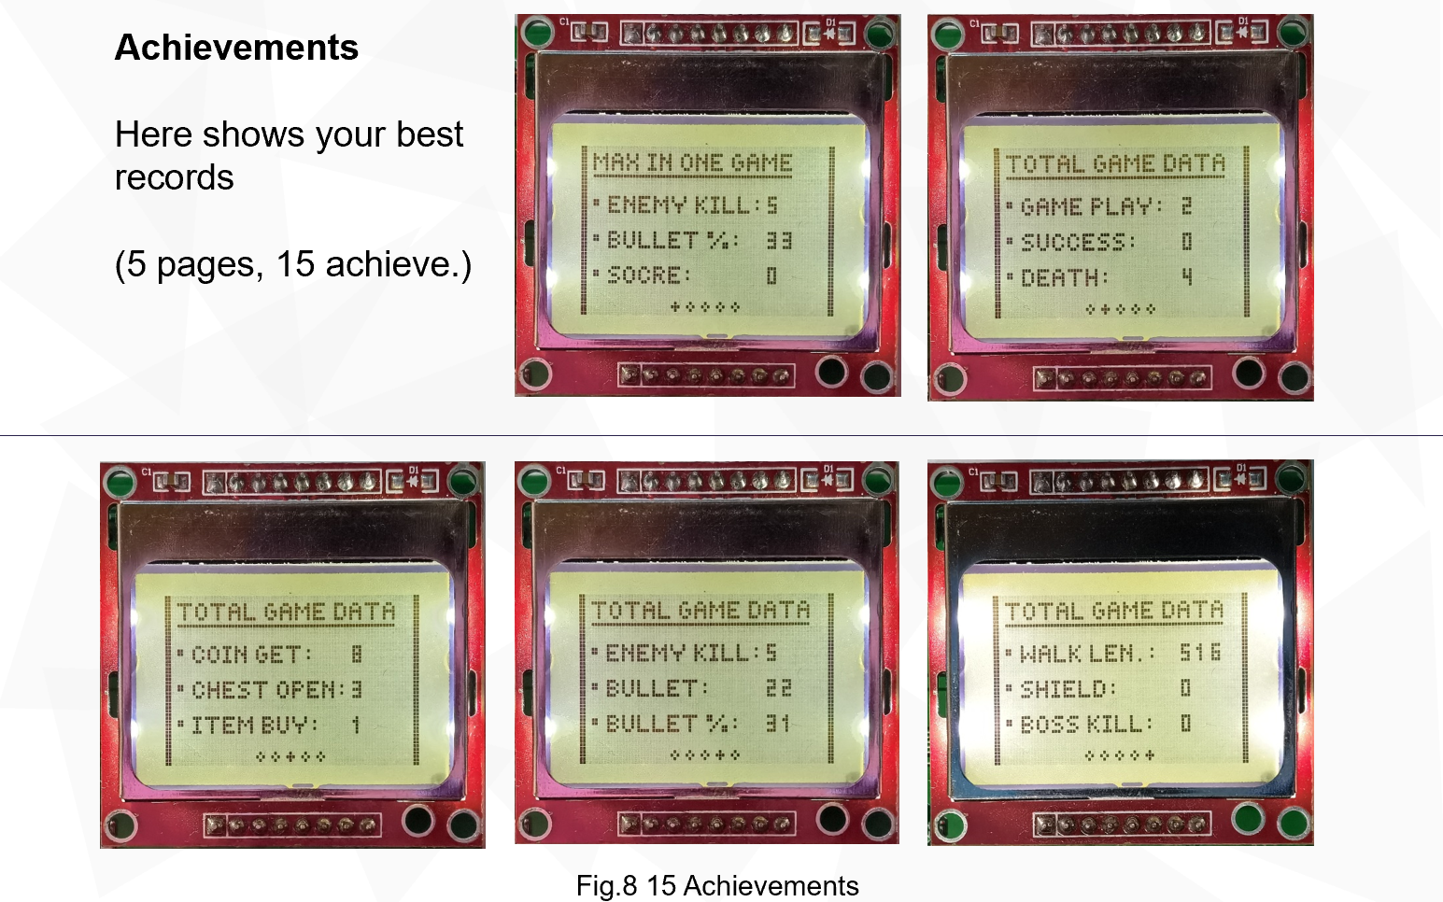

1. Others

* Endless game levels, with difficulty increasing exponentially.
* Fantastic background music (Zelda) and fire & interact sound effects.
* Adjust the screen brightness to the light.
* ShiftReg LED and LPC1768-on-board LEDs are used to show player’s lives left, and ultimate skills left correspondingly. (Fig.9)
* Limit the game frame rate to 12 fps to prevent flickering when the lcd is refreshed too fast for complete rendering.
* The program is written based on fsm and modularity, which makes it possible to create tutorial levels by adding only tens of lines of code.

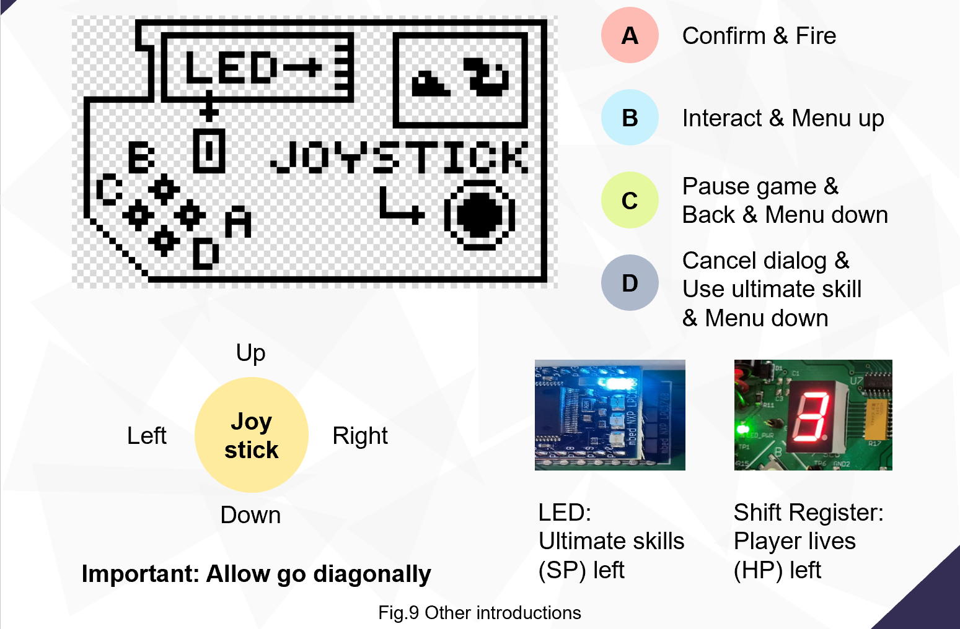

**📃 PDF version:**